- Create a new branch
- List all the available branches
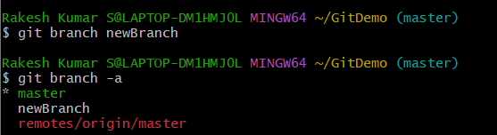
- Switch over to newly created branch
- Add a new file
- Commit the changes
- Check the status to ensure the branch is clean
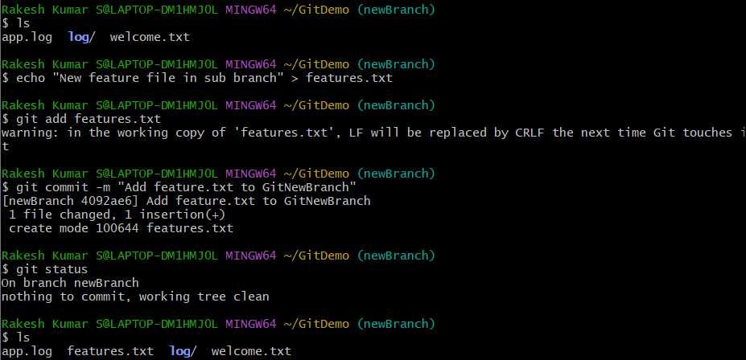
- Switch back to the master branch
- List out the command-line differences between the trunk and the branch:
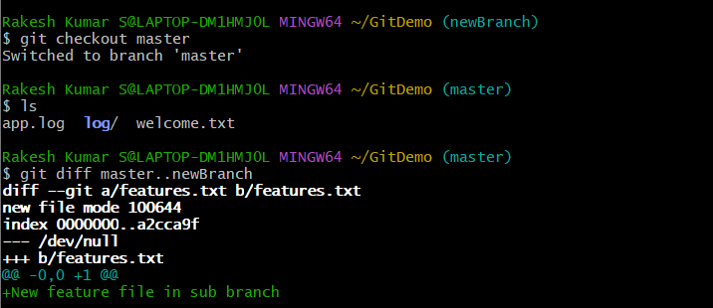

- Observe the logging to see a visual graph
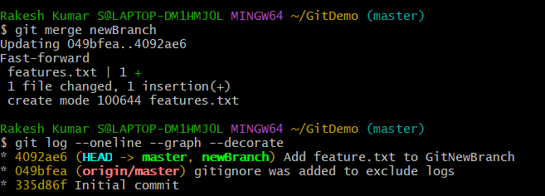
- Delete the branch after merge completion
